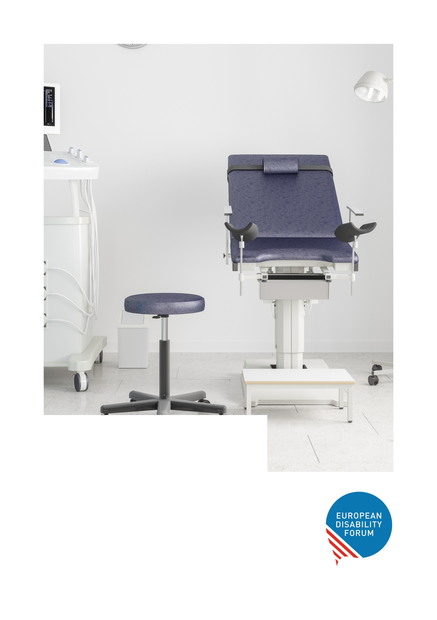
The European Disability Forum is calling for the criminalisation of forced sterilisation
practices across Europe.

A silenced truth:
Stories of forced sterilisation in the EU

Content
Introduction 3
What is forced sterilisation? 3
The most targeted 4
Statistics on Forced Sterilisation 4
Our demands 5
Legislative context and state of play at European level 6
A silenced truth: Real-Life Stories 6
‘I asked myself: What have they done with my life? Am I useless? Can everyone be a mother except me?’ 6
‘I was not happy. I still wanted children. I was upset against my parents because I found this [to be sterilised] very unfair.’ 7
'I see the scar and I want to die' 7
‘There are probably sterilisations carried out without real consent’ 7
‘There are still too many opportunities for abuse and - not to forget - a lot of emotional pressure on women to get them to agree to sterilisation’. 8
Glimmers of hope. EU countries banning forced sterilisation 8
Sweden 8
Spain 9
Czechia 9
Malta 9
Related information 10

Introduction

The European Disability Forum (EDF) – the umbrella organisation of persons with disabilities that defends the interests of over 100 million persons with disabilities in Europe is calling for the respect of the sexual and reproductive rights of persons with disabilities, particularly of women and girls with disabilities.
This includes the right to choose whether to have children or not.
Subjecting persons with disabilities to harmful practices constitutes a pervasive abuse and a flagrant violation of their fundamental rights.
Allowing forced sterilisation in Europe is accepting an intrusive form of violence that destroys survivors’ lives. It causes long-lasting trauma pain and supports a biased system that doubts the ability of persons with disabilities, frequently women with disabilities, to care for a child and establish a family.
#EndForcedSterilisation

What is forced sterilisation?

Sterilisation can be defined as a process resulting in a permanent incapacity of natural reproduction. This process is:
- Forced, when sterilisation occurs without a person's knowledge or against their explicit refusal, or when there is no serious and immediate threat to health or life.
- Coerced, with pressure coming from family, medical professionals, or being mandated by policies or legislation, like requirements for accessing services or making legal document changes.

The most targeted

Although all persons with disabilities in Europe are at risk of being targeted, the following groups are among the most vulnerable to forced sterilisation without their consent:
- People with intellectual or psychosocial disabilities, especially those under guardianship measures.
- Women and girls with disabilities, and all those that can carry pregnancies.

Statistics on Forced Sterilisation
International human rights treaties prohibit forced sterilisation due to its violations of fundamental rights, such as dignity, physical integrity, privacy, and free and informed consent. However, EDF's September 2022 report uncovered concerning data regarding forced sterilisation practices across the European Union:
- It is still legal in several EU countries: 13 out of the 27 EU Member States still authorise forced sterilisation. These include: Bulgaria, Croatia, Cyprus, Czechia, Denmark, Estonia, Finland, Hungary, Latvia, Lithuania, Malta, Portugal and Slovakia
- The absence of criminalisation: Only 9 EU Member States explicitly criminalise forced sterilisation as a distinct offence in their criminal code.
- It affects minors: Czechia, Hungary and Portugal allow forced sterilisation of minors.
- It is a mandatory requirement: In at least 3 EU Member States the use of contraception or sterilisation can be a requirement for admission to residential institutions: Belgium, France and Hungary.
- It is a taboo: The total number of forced sterilisations carried out in Europe remains unknown. There are no official figures that could shed light on it.

Our demands
EDF calls upon the Council of the EU and the European Commission for the prohibition and criminalisation of forced sterilisation across the EU and its Member States.
We call specifically for:
- The criminalisation of forced sterilisation
  - Under the proposed EU Directive on combating violence against women and domestic violence, and
  - By all EU Member States with no exception based on disability or legal capacity.
- The adoption of measures at both EU and Member States levels to ensure access to justice, including adequate criminal sanctions, and compensation for victims.
- The ratification of the Istanbul Convention by the following EU Member States: Armenia, Azerbaijan, Bulgaria, Czechia, Hungary, Latvia, Lithuania and Slovakia.

Legislative context and state of play at European level

- In March 2022 the European Commission presented a proposal for a Directive on Combating Violence Against Women and Domestic Violence to the European Parliament and the Council.
- In June 2023, the European Council adopted its position.
- In July 2023, the European Parliament adopted its position.
- Now the text is undergoing further negotiations with the Council of the EU, representing Member States, and the European Commission.

A silenced truth: Real-Life Stories
These are some of real stories of persons with disabilities who have endured forced sterilisation. Their experiences shed light on the grave violation of their rights, as they share their life trauma.
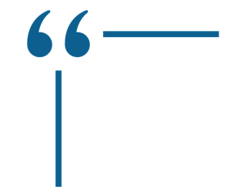
Please note that some of their personal data has been changed to preserve their identity and privacy.
‘I asked myself: What have they done with my life? Am I useless? Can everyone be a mother except me?’
Rosario Ruiz, 53, is diagnosed with a 67% intellectual disability. When she turned 20, Rosario fell in love with Antonio, a colleague at an occupational centre in Seville, Spain. They discussed their desire to have children one day. The idea of Rosario being a mother was a shock for her parents. Following advice from their family doctor, Rosario was sterilised.
Read Rosario’s complete testimonial. Retrieved from Euronews.

‘I was not happy. I still wanted children. I was upset against my parents because I found this [to be sterilised] very unfair.’
Women with intellectual or psychosocial disabilities and a legal guardian can also be forcibly sterilised in EU countries under certain conditions. Monique, residing in Belgium, shares her story of discovering that she had undergone sterilisation with her parents’ authorisation.
Watch Monique’s complete testimonial. Retrieved from ZDF.

'I see the scar and I want to die'
Carmen has an intellectual disability, and her mother took her to hospital without telling her where she was going. "When I signed the papers, my vision was blurry because I was already under anaesthesia. I signed without consenting, because when I asked, they just told me to sign it," she adds. She didn't know what was going to happen until the doctor explained it, but by then it was too late, as she was already in surgery.
Retrieved from Euronews. Read the complete testimonial.

‘There are probably sterilisations carried out without real consent’

Dr Catherine Rey-Quinio, medical advisor of Ile-de-France Regional Health Agency, has received an average of two to four requests for sterilisation per year over the past decade but only two in the last four years.
Read Dr Rey-Quinio’s complete testimonial. Retrieved from Euronews.

‘There are still too many opportunities for abuse and - not to forget - a lot of emotional pressure on women to get them to agree to sterilisation’.
Helene Middelhauve, from the Gender-Specific Violence Reporting Unit at the German Institute for Human Rights, identifies a need for improvement in Germany. According to the German Institute for Human Rights, women with disabilities undergo sterilization at a rate 8 times higher than women without disabilities.
Read the full article from ZDF.

Glimmers of hope. EU countries banning forced sterilisation
All these EU countries have criminalised forced sterilisation in their national laws. Change is possible!

Sweden
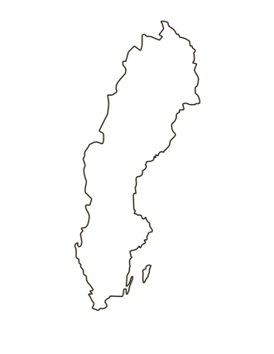
Sweden has a significant history of forced sterilisation from 1934 to 1975. However, after abolishing forced sterilisation in 1975 Sweden set up a government body to compensate people who had been forcibly sterilised.

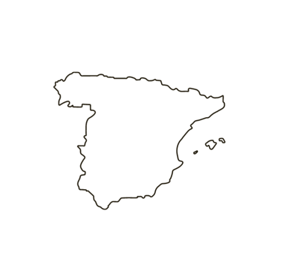
Spain
In Spain in December 2020 forced sterilisation, which was previously allowed for persons "incapable of giving consent," was criminalised.

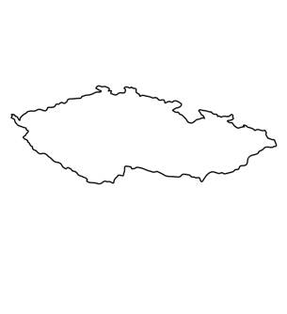
Czechia
Czechia has a history of forced sterilisation of Roma people and persons with disabilities. Initially, the victims had recourse only to a common civil remedy, which was deemed sufficient by the country. However, in 2021, Czechia passed a law to compensate victims of forced sterilisation, responding to pressure from civil society and a recommendation from the UN Committee on the Rights of Persons with Disabilities.

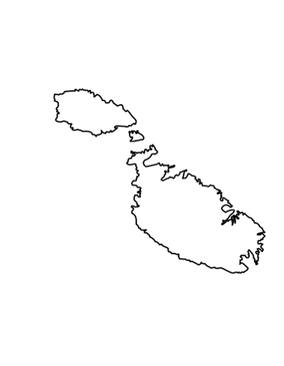
Malta
Malta announced that it is in the process of completely criminalising the forced sterilisation of persons with disabilities. A proposed legislation will be examined soon by its Parliament.

Related information

- All about the campaign to End Forced Sterilisation available on EDF website.
- EDF report “Forced sterilisation of persons with disabilities in the European Union”. Also available in Easy to Read and in International Sign Language.

Contact

Marine Uldry – EDF Human Rights Policy Coordinator: marine.uldry@edf-feph.org
For press/media contacts, please refer to press@edf-feph.org
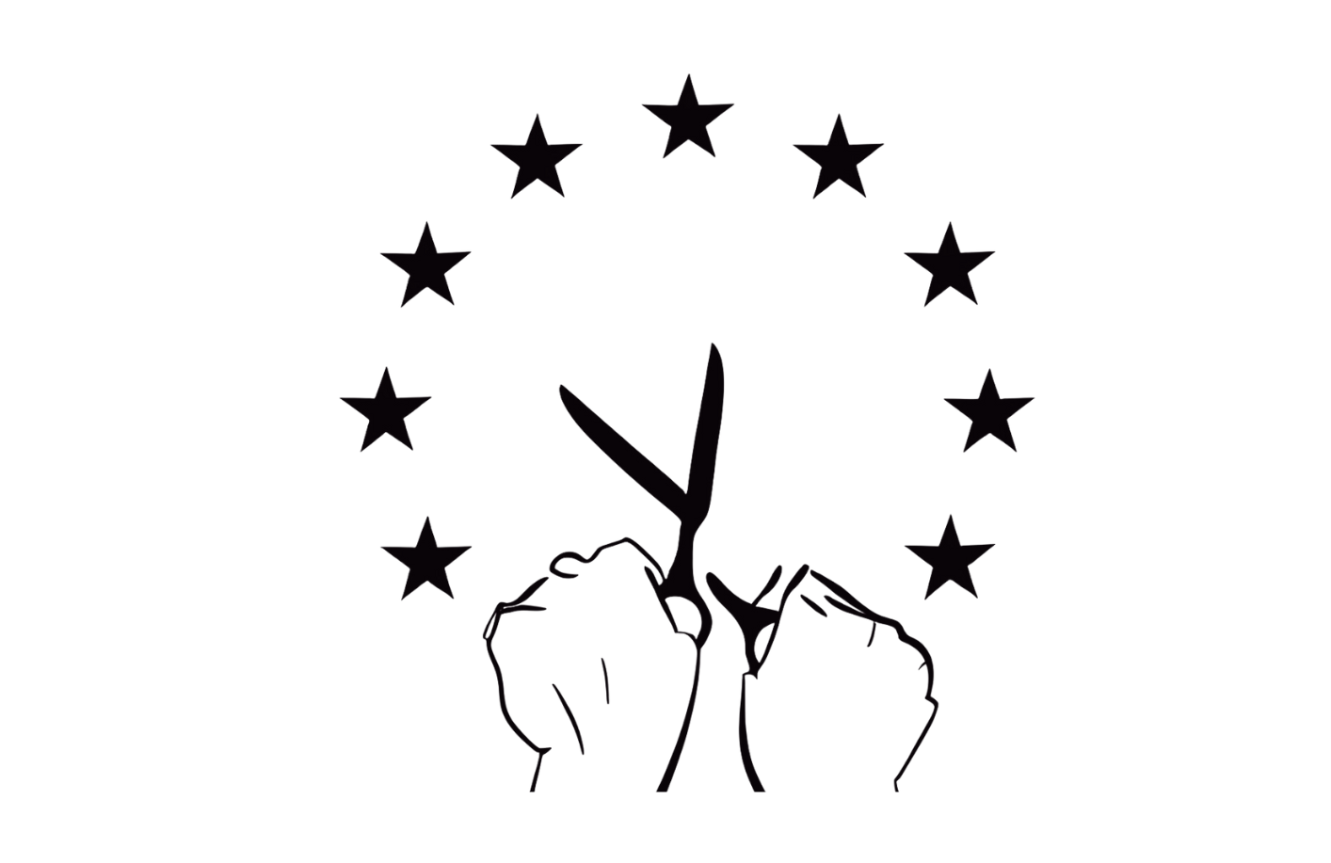
The European Disability Forum
Mundo Madou. Avenue des Arts 8 Brussels, Belgium

