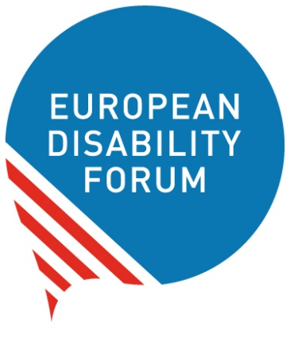

How the European Union
can use its money
to promote independent living


Easy-to-read
Easy-to-read is information
that is written in a simple way
so that people with intellectual disabilities
and all people can understand it.
You can find more information about easy-to-read
at www.inclusion-europe.eu/easy-to-read.

Who we are
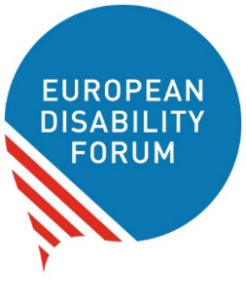
We are two organisations that work
to protect the rights of people with disabilities
in Europe:
- The European Disability Forum
In short: EDF
and
- The European Network on Independent Living
In short: ENIL
We believe that people with disabilities
should be part of the community
and make their own choices in life.
Nothing should be decided about us without us!


What this booklet is about
We made this booklet to talk about
how the European Union can use its money
to promote independent living
for all people with disabilities in the world.

All the difficult words in the text are marked in bold
and you can find their explanation at the end of this booklet.

Independent living
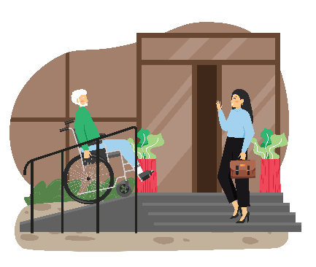
Independent living means
you can make your own choices about your life.
For example, you can choose
where, how and with whom you want to live.
All people have the right to live independently
and to be part of the community.

Sadly, in practice,

many people with disabilities
do not enjoy their right to live independently
like other people.
They may:

- Live in institutions
away from their families and friends.
- Not be allowed to make their own choices
about their lives.
- Not get the support they need to be able
to take part in the community like other people.

The role of the European Union

The European Union has signed
‘the UN Convention on the Rights
of Persons with Disabilities’.
In short, we call it ‘the UN Convention’.
The UN Convention is an agreement that says
what rights people with disabilities have
and how countries should protect these rights.
Amongst others, the UN Convention says
that people with disabilities have the right
to live independently and to be part of the community.


By signing the UN Convention,
the European Union agreed to do
what the UN Convention says
to protect people with disabilities.
The European Union should respect
what the UN Convention says in everything it does.
That means in the way it spends its money too.

Use of European Union’s money
The European Union gives a big amount of money
to help countries in the world that are in need.
For example, countries that are poor.

This money is used to help people in these countries
to have a better and safer life.
For example, to have access to clean water and food
and to build schools and hospitals.

This money should be used
to help people with disabilities too.
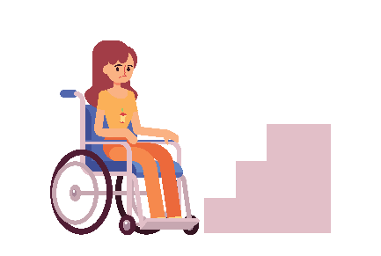
For example, it should be used to:

- Make things and services accessible
so that people with disabilities
can use them to take part in the community.

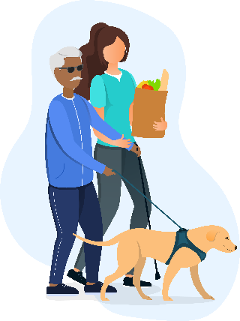
- Create services that help
people with disabilities to live independently.
For example, some people with disabilities may need a support person to help them
in their daily life.
Sadly, in practice,
some of this money is used in projects
that do not promote independent living
for people with disabilities.
For example, it may be used for institutions
where people with disabilities live
away from the community.

This is against the rights in the UN Convention
and the European Union needs to stop it.

Promoting independent living
The European Union should make sure
that the money it gives to countries in need
is used in a way that respects
the rights of people with disabilities.
Amongst others, the European Union should:

- Spend its money on projects
that support people with disabilities
to live independently.
- Not support institutions
where people with disabilities live
away from the community.

- Check if countries use this money
for the good of people with disabilities
and all people.

- Listen to organisations
of people with disabilities
when it plans how it will use its money.

More information
For more information about our work,
you can check:
- The website of the European Disability Forum
- The website of the European Network
on Independent Living
If you have any questions,
you can send us an email at:
info@edf-feph.org.

Explanation of difficult words

European Union
The European Union is a group of 27 countries in Europe
that work together to make things better for their people.
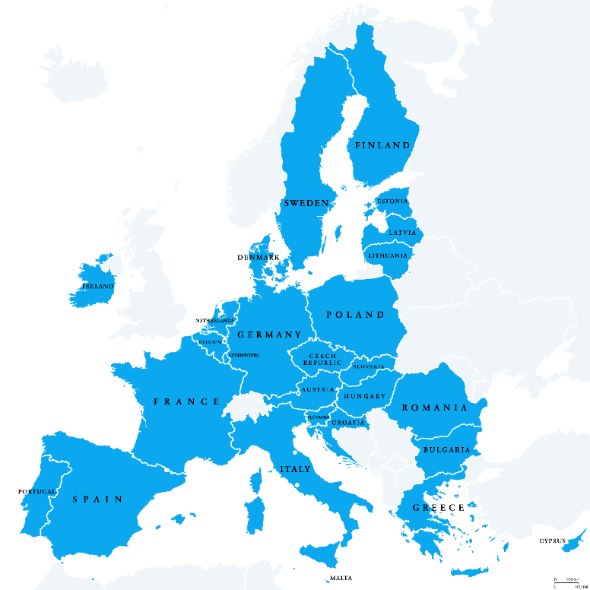

Institutions
Institutions are places
where people with disabilities live
away from other people
and from the community.
Often, people who live in institutions
must follow the rules of the institution
and cannot decide for themselves.

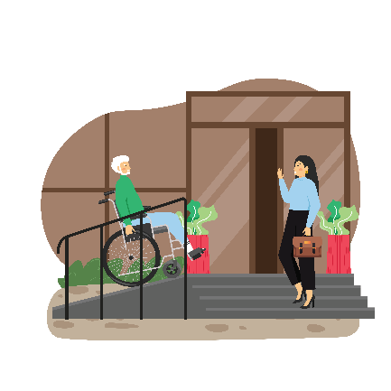
Accessible
Things are accessible
when they are easy to use
for people with disabilities and all people.
For example, when buildings have ramps
that people in wheelchairs can use to get in.
Or when information is easy to read
and people with intellectual disabilities
can understand it.

